FD COLCHAGUA VALLEY

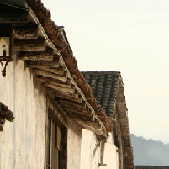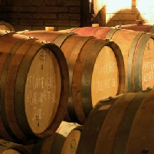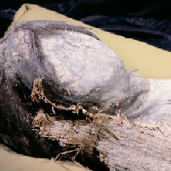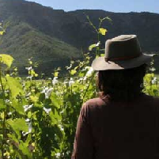

Chile has become a big league player in the global wine market in recent decades. And no other region in the country stands out as much as the Colchagua Valley, this valley was internationally recognized as the “2005 World’s Best Wine Region”, granted for the first time in its history to a South American wine region. Colchagua is approximately 150 kms (93 miles) south of the capital city, Santiago, and it´s truly blessed when it comes to producing red wines (Cabernet Sauvignon, Merlot, Syrah, and many good Carmenère and Malbec wine). Warm and naturally dry, but with an abundant water supply from the Tinguiririca River, Colchagua is a narrow agricultural valley that begins at the foot of the Andes and extends west to the Pacific.
Our first stop will be Viña Casa Silva where we will visit the winery, one of the oldest and most beautiful in Chile. This vineyard is entirely run by the Silva family and each member participates actively in its daily management, working with a passion, commitment and dedication that you can only find within a family business that feels absolutely anchored to its land and traditions. We continue to the Colchagua Valley Museum.
The Colchagua Museum was designed to show the concept of a journey through the history of the planet and mankind in the Americas. The tremendous variety of collections that its founder Carlos Cardoen has gathered over the years allows visitors to explore paleontology, archaeology, and Pre-Colombian art from Chile and throughout the Americas, as well as the History of the Spanish Conquest, Colonial times and the Independence of Chile and the Americas and through the Republican era. It also includes themed rooms dedicated to such topics as Modernity, the History and Development of Arms, traditional huaso gear, Coaches and Carriages, Agricultural Machinery, and the Chilean Railroad.
Located in Santa Cruz, 200 km (125 mi) south of Santiago, the Colchagua Museum is the largest and most diverse private museum in Latin America. The museum is in the heart of the Colchagua region, a tradition-filled rural area, home to the huaso (the traditional Chilean countryman), and where the traditional festivals and way of life are still celebrated and conserved.
Viña Santa Cruz is located near the small town of “Lolol”, which is in the Sixth Region, 33 k southwest of Santa Cruz. It was declared a typical Chilean zone for exemplifying the characteristics and values of rural Chilean life. This winery’s mission is to make high quality wines using the most modern technology with the aid of the unique characteristic and traditions of the beautiful Lolol Valley. Here we enjoy a tour and wine tasting of the fruits of this modernized vineyard. After our tour we return to Santiago.

Technical Details

Availability: Tuesday-Sunday (Subject to availability).
Departure Time: 08:00 a.m.
Duration: 10 Hrs
Capacity: No limit.
1 | 2 | 3 | 4 | 5

Difficulty: Easy Most Strenuous
Local People Contact:

Highlights: Colchagua Valley, Viña Casa Silva, Colchagua Museum, Viña Santa Cruz, Wine tasting and demonstration of wine production processes.
Meals included: Lunch (menu)
Special Requirements: None.
Type of accommodation: N/A
Shopping opportunities: Yes
Access to toilets: Yes
We suggest bringing: Comfortable clothing, sun protection and camera.

Excursion includes

- Transport.
- Bilingual Specialist Guide drivers.
- Tour.
- Wine tasting.
- Lunch (menu).
- Tips for lunch.

Excursion does not include

- Anything not mentioned in the above description and details.

Cancellation Policy

- General Terms and Conditions apply.

